E-COMMERCE BUSINESS ANALYTICS
Comprehensive Business Analysis Report

Dataset: Online Retail II (UCI Machine Learning Repository)

Final Project

BA2006-Fundamentals of Business Analytics
Course Instructor:
Ma’am Aiza Aftab
Section
BS(BA)-4A
Submitted By:

Group Members:
- Taha Hassan Tahir (24L-5076)
- M.Rai Abdul Wassey(24L-5030)
- Saad Ishfaq (24L-5064)
- M.Saad Bin Asim (24L-134)
- M.Salman Qasim (24L-5167)
- M. Hamza Tarar (24L-5116)

Table of Contents
1. Executive Summary 4
2. Introduction 4
2.1 Background 4
2.2 Problem Statement 5
2.3 Objectives 5
2.4 Dataset Source 5
3. Dataset Description 5
3.1 Dataset Overview 5
3.2 Missing Values Before Cleaning 6
4. Data Cleaning 6
4.1 Missing Values 6
4.2 Duplicate Removal 7
4.3 Removing Irrelevant Records 8
4.4 Outlier Detection and Removal 8
5. Data Wrangling 9
5.1 Column Renaming 9
5.2 DateTime Feature Extraction 9
5.3 Derived Columns 9
5.4 Encoding Categorical Variables 10
6. Exploratory Data Analysis 10
6.1 Target Variable - Revenue Distribution 10
6.2 Univariate Analysis - Numerical Features 11
6.3 Univariate Analysis - Categorical Features 12
6.4 Bivariate Analysis 14
6.5 Multivariate Analysis 16
7. Statistical Analysis and Hypothesis Testing 19
7.1 Descriptive Statistics 19
7.2 Test 1 - One-Sample T-Test 19
7.3 Test 2 - Mann-Whitney U Test 20
7.4 Test 3 - One-Way ANOVA 21
7.5 Test 4 - Kruskal-Wallis Test 22
7.6 Test 5 - Chi-Square Test 23
7.7 Summary of All Hypothesis Tests 24
8. Regression Analysis 25
8.1 Model 1 - Simple Linear Regression with Quantity and Price 25
8.2 Model 2 - Simple Linear Regression with Quantity and Geography 26
8.3 Multiple Linear Regression 27
8.4 Three-Model Pipeline Comparison 28
8.5 Polynomial Regression 29
8.6 Neural Network Regression 30
8.7 Summary of All Regression Models 30
9. Customer Segmentation – K-Means Clustering 31
9.1 RFM Framework 31
9.2 Finding the Optimal Number of Clusters 31
9.3 Cluster Results 32
9.4 Cluster Visualisation 33
10. Business Insights and Recommendations 34
10.1 Key Findings Summary 34
10.2 Recommendations 34
11. Conclusion 35
12. References 37

1. Executive Summary
This report is a comprehensive business analytics project on the UCI Machine Learning Repository data source Online Retail II. The data set consists of actual transactions from an online retailer in the UK from December 2009 to December 2011. The analysis follows a full pipeline from data cleaning to regression modelling to customer segmentation, to business recommendations.
This project was undertaken by a team of six students from their Business Analytics course. All the important topics covered in this course such as: Data cleaning, exploratory data analysis, statistical testing, regression (simple, multiple, polynomial and neural network), and K-Means clustering.
Metric | Value
Raw Records | 1,067,371
Records After Cleaning | Approx. 500,000+
Unique Customers | 5,878+
Unique Countries | 41
Date Range | Dec 2009 – Dec 2011
Regression Models Built | 4 (Simple, Multiple, Polynomial, Neural Net)
Hypothesis Tests Conducted | 5
Customer Segments Identified | 3 (VIP, Active, Lost)
Key findings are that Q4 is the most profitable season, the UK is the largest transaction volume market, and non-UK transactions are higher in terms of revenue per order and 3 customer segments were identified using RFM based K-Means clustering. Recommendations are offered for marketing, inventory, and customer retention.

2. Introduction

2.1 Background
Ecommerce businesses produce a great deal of data regarding transactions on a daily basis. With analysis, this data can provide insights into customer behavior, product performance, and revenue trends. Business analytics provides us with the means to turn all of this back into meaningful information to inform managers and decision makers in more effective planning. In this project, we leverage business analytics methods on a real-world e-commerce data set to solve a set of problems such as: Who are our best customers? At what times are we rewarded for our work? What are the bestsellers? How will the revenue be in the upcoming months?

2.2 Problem Statement
The problem with ecommerce businesses is that they don't know who their customers are, what they are buying, and the time of the day they will buy. If left unanalyzed, businesses may find themselves running short of stock during busy seasons, not be aware that they have lost their top customers, and waste their marketing dollars on the wrong people. This project tackles these issues by leveraging data analysis.

2.3 Objectives
- Clean and prepare the raw transactional dataset for analysis.
- Explore the data through charts and statistics to find patterns and trends.
- Test statistical hypotheses to confirm findings with evidence.
- Build regression models to predict revenue.
- Segment customers into groups using K-Means clustering.
- Generate practical business recommendations based on the findings.

2.4 Dataset Source
The Online Retail II dataset which is used in this study was originally published by Dr. Daqing Chen at the UCI Machine Learning Repository. It contains all the transactions from a UK-based online gift retailer between December 2009 and December 2011. Most of its customers are wholesalers from different countries.

3. Dataset Description

3.1 Dataset Overview
The raw dataset contains 1,067,371 rows and 8 columns. Each row depicts one line item in a customer transaction. The description of each column is given below:
Column | Type | Description
Invoice | Text | Invoice number. If it starts with C, the order was cancelled.
StockCode | Text | Product code. Dropped during cleaning as not needed for analysis.
Description | Text | Product name. Missing values filled with Unknown.
Quantity | Integer | Number of units sold. Negative means a return.
InvoiceDate | DateTime | Date and time of transaction. Converted to datetime format.
Price | Float | Unit price in British Pounds.
Customer ID | Integer | Unique ID for each customer. Missing values removed.
Country | Text | Country where the customer is based.

3.2 Missing Values Before Cleaning
Column | Missing Values | Percentage Missing
Description | 4,382 | 0.41%
Customer ID | 243,007 | 22.77%
All Other Columns | 0 | 0.00%

4. Data Cleaning

4.1 Missing Values
The first step was to check for the missing values in all columns. A bar chart was plotted to visually describe which columns had how much missing data. Two columns had missing values: Customer ID at 22.77% and Description at 0.41%.
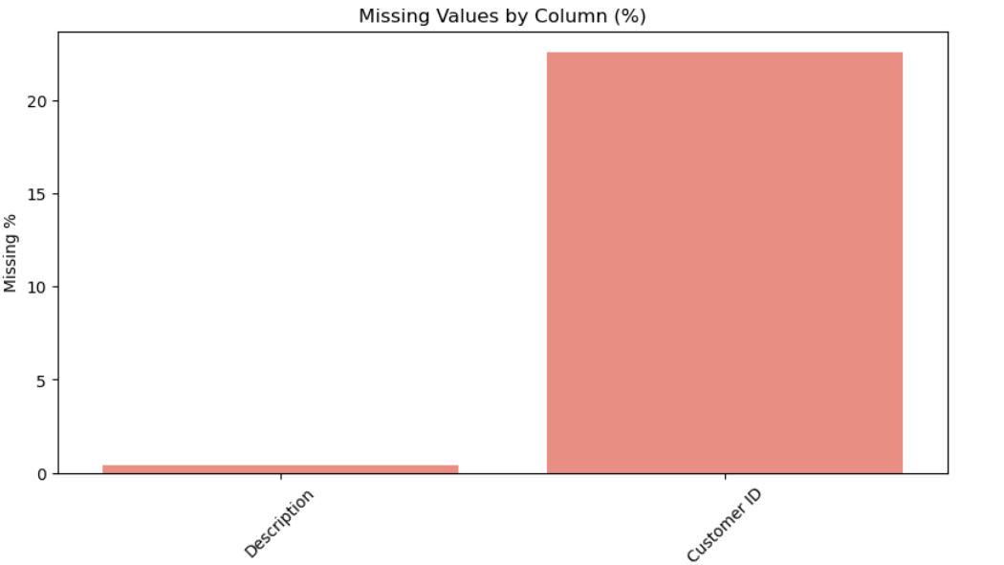
Figure 1: Bar chart showing percentage of missing values per column. Customer ID has the highest missing rate at 22.77%.

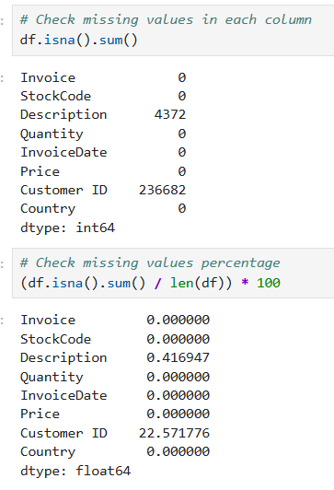
- Customer ID rows were dropped because customer identity is needed for all customer-level analysis. Rows without a Customer ID cannot be linked to any buyer.
- Missing Description values were filled with the word Unknown so the rows can be kept for revenue analysis.

4.2 Duplicate Removal
We have removed the missing values from the dataset and then checked for duplicate rows in the data set. Any exact duplicates were removed using the drop_duplicates() function. This way, the same transaction won't be recorded twice.

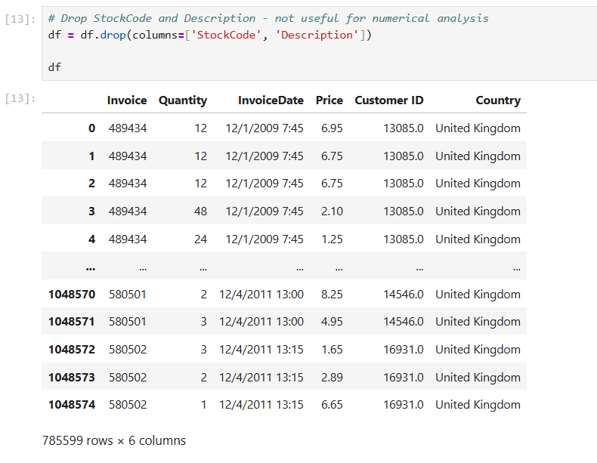

4.3 Removing Irrelevant Records
The data set was reduced by eliminating three types of records:
- Cancelled orders (Invoice numbers beginning with C), these are refunded/reversed transactions and do not represent actual sales.
- Data errors or returns are indicated by rows that have Quantity <= 0 or Price <= 0.
- The StockCode and Description columns were also deleted because they are not used in the numerical analysis.

4.4 Outlier Detection and Removal

Quantity Outliers
Boxplots was used to visualise the number of outliers, before and after data cleaning, in the Quantity column. There were extreme values in the raw data, with one transaction having 80,995 units. Data with outliers were removed using the IQR method, where any Quantity greater than Q1 – 1.5 x IQR or less than Q3 + 1.5 x IQR was excluded.
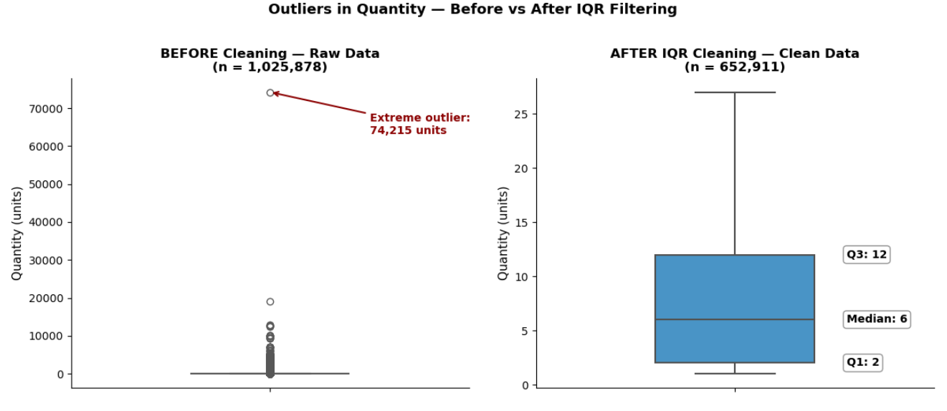
Figure 2: Left panel shows raw data with extreme outliers. Right panel shows cleaned data after IQR filtering with Q1, Median, and Q3 annotated.

Price Outliers
The same interquartile range procedure was used for the Price column. The two-panel boxplot displays the entire range of prices with an outlier (extreme maximum) on the left and the IQR range zoomed in on the right to show the actual price distribution.
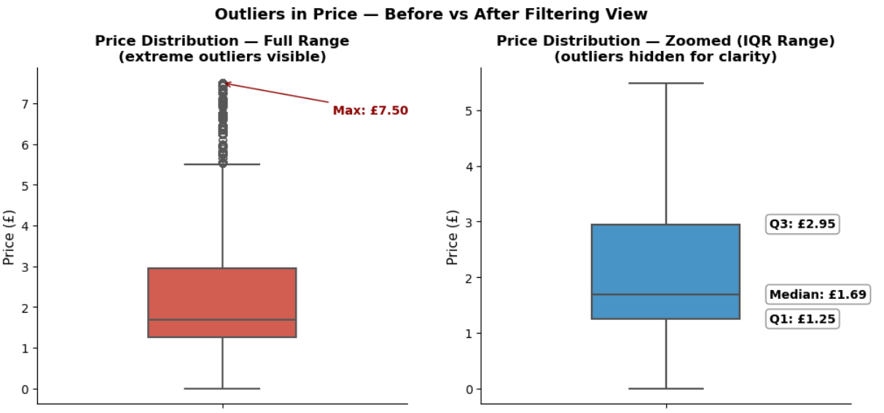
Figure 3: Left panel shows extreme price outliers. Right panel is zoomed to the IQR range with Q1, Median, and Q3 annotated.

5. Data Wrangling

5.1 Column Renaming
All column names were converted into lowercase with the spaces replaced by underscores. For example, Customer ID became customer_id. This helps in making the code cleaner and avoids errors when referencing columns.

5.2 DateTime Feature Extraction
The invoice date column was converted to datetime format. Also several new time-based features were extracted in order to support trend and seasonality analysis:
New Column | Description
month | Month number from 1 to 12
month_name | Month name such as January or February
quarter | Quarter number from 1 to 4
day_of_week | Day name such as Monday or Tuesday
year | Year of the transaction
hour | Hour of the day the order was placed

5.3 Derived Columns
Six new columns were created from existing data to support deeper analysis:
Column | How It Was Created | Purpose
total_revenue | quantity multiplied by price | Primary variable for all revenue analysis
revenue_segment | Divided into Low, Medium, High, Premium bins | Classify transactions by revenue size
price_tier | Divided into Budget, Mid, Premium, Luxury bins | Classify products by price range
high_value | 1 if revenue above median else 0 | Binary flag for high-value transactions
purchase_count | Number of unique invoices per customer | Measures customer purchase frequency
customer_segment | Divided into One-Time, Occasional, Regular, Loyal | Classify customers by loyalty level

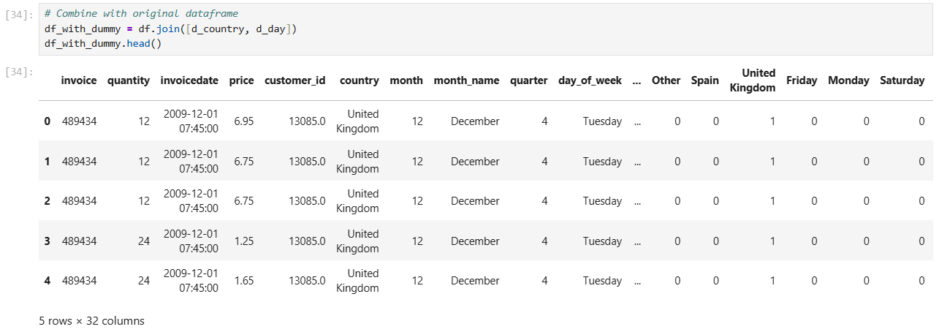

5.4 Encoding Categorical Variables
Two categorical columns were encoded into dummy binary variables for use in machine learning models:
- Country - Top 5 countries were kept as separate columns, all others were grouped as Other.
- Day of Week - Each day was converted to a binary column showing 1 if that day and 0 otherwise.
These dummy variables were then joined to the main dataset as additional columns for use in regression models.

6. Exploratory Data Analysis

6.1 Target Variable - Revenue Distribution
The revenue_segment column categorizes all transactions into four segments: Low (0 to 10 pounds), Medium (10 to 50 pounds), High (50 to 200 pounds), Premium (above 200 pounds). Most transactions are in the Low and Medium transaction category, indicating that most individual transactions are small dollar transactions. This is normal for the selling of a lot of low-priced products to a retail business.
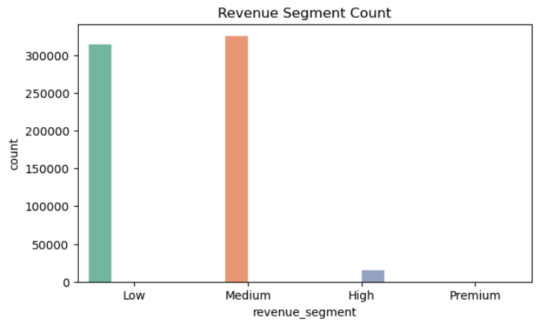
Figure 4: Bar chart showing number of transactions per revenue segment. Low and Medium segments dominate.
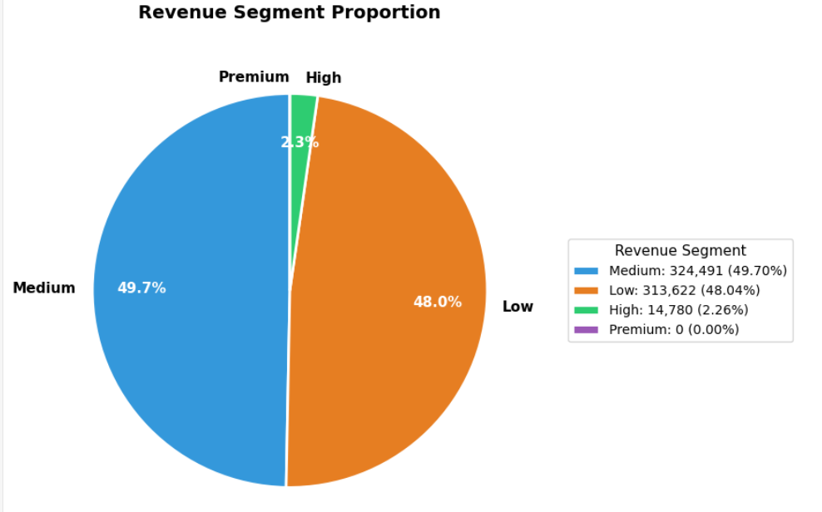
Figure 5: Pie chart showing percentage share of each revenue segment. Premium transactions are rare but significant in value.

6.2 Univariate Analysis - Numerical Features
All of the major numerical variables were plotted to see the shape and spread of the variables. Each of the four distributions is right-skewed (the bulk of the values are low with a few unusually high values). This is typical of data from sales.
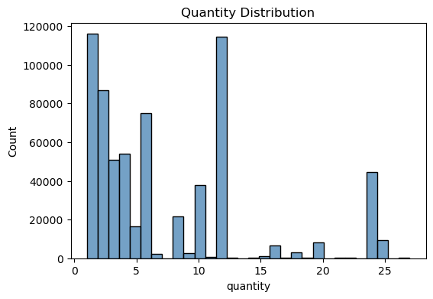
Figure 6: Most orders involve small quantities. A right skew is visible.

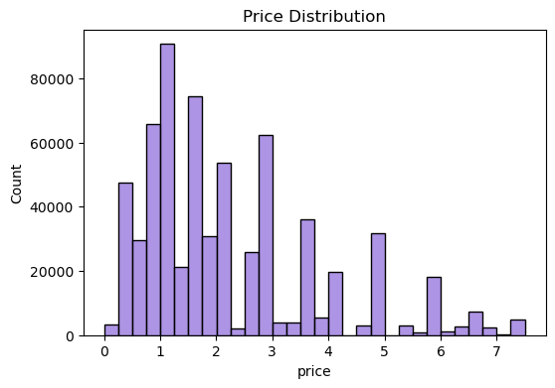
Figure 7: Most products are priced under 10 pounds. A few expensive items create the right tail.
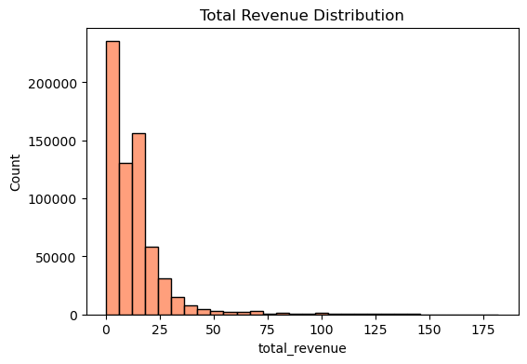
Figure 8: Most transactions generate low revenue. The distribution is heavily right-skewed.
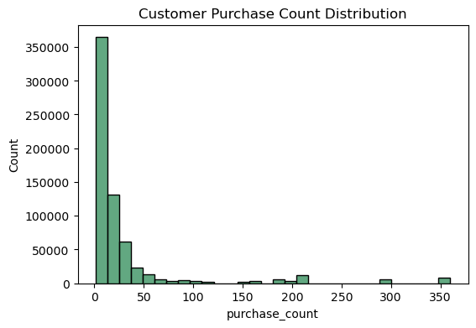
Figure 9: Most customers have made only a few purchases. A small group of loyal customers has very high purchase counts.

6.3 Univariate Analysis - Categorical Features

Country Distribution
The United Kingdom leads by a wide margin in transactions. A two-panel chart was used, the first panel featuring all top 10 countries at full size in order to emphasise the dominance of the UK, while a zoomed-in view of the countries in the top 10 at No. 2 to No. 10 is shown in the second panel to make it easier to see how the various markets are competing.
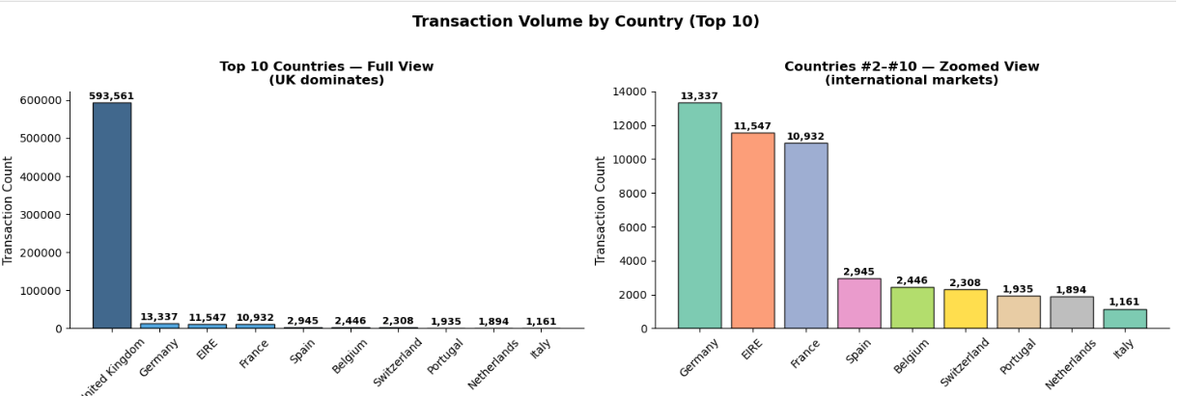
Figure 10: Left panel shows full scale with UK dominating. Right panel zooms into international markets ranked 2 to 10.
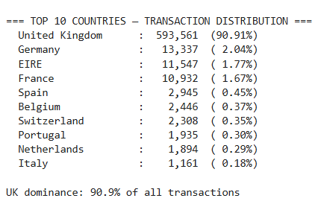

Customer Segment Distribution
The bulk of customers are in the One-Time and Occasional segments, having bought just one or a few times. There is a smaller number of Regular and Loyal customers and they are the ones that are valuable to keep.
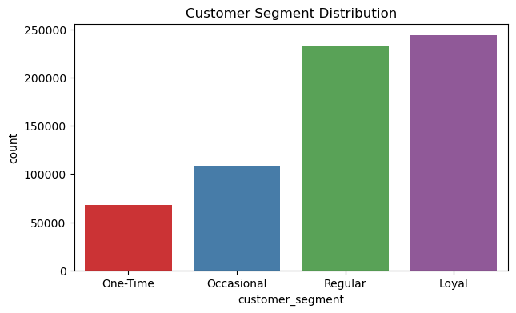
Figure 11: Most customers are One-Time buyers. Loyal customers are the smallest but most valuable group.

Price Tier and Day of Week
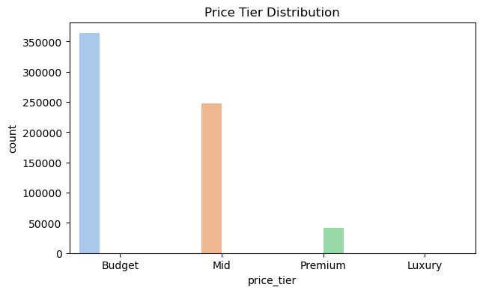
Figure 12: Most products fall in the Budget and Mid price tiers. Luxury products are rare.

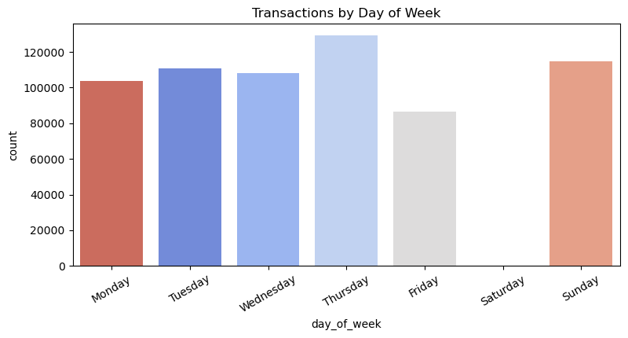
Figure 13: Weekdays especially Thursday have the highest transaction counts. Saturday has nearly zero transactions.

6.4 Bivariate Analysis

Revenue by Customer Segment
Total revenue is compared by the four customer segments using a box plot. The mean and median revenue for each group is indicated on the graph. It's clear that Loyal customers produce more Average Revenue per transaction (ART) than do customers who are One-Time customers.
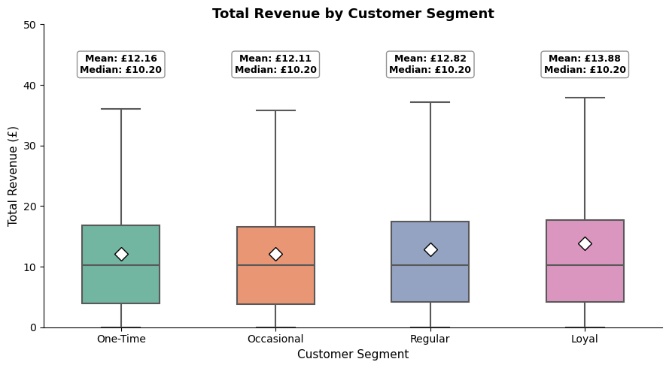
Figure 14: Loyal customers have higher average revenue per transaction. Mean and Median are both shown for each segment.

Revenue by Price Tier
As predicted, the more expensive Tiers result in more revenue per transaction. The box plot is used to verify the above observations, illustrating that Budget products have the lowest median revenue compared to the Luxury products.
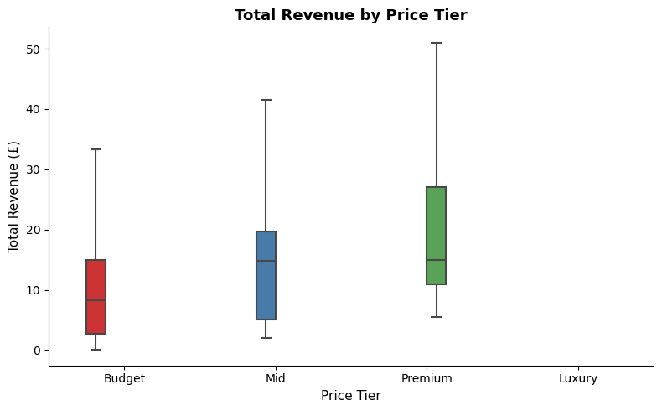
Figure 15: Luxury and Premium products generate significantly higher per-transaction revenue than Budget items.

Monthly Revenue Trend and Quarterly Revenue
Average monthly revenue displays a clear pattern i.e. it dips in the first quarter of the year and rises significantly towards Q4, confirming powerful holiday season seasonality.
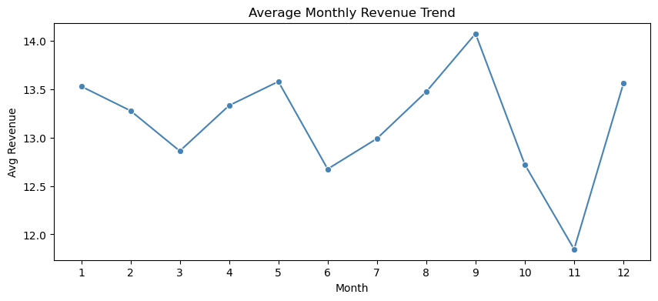
Figure 16: Revenue is lowest in early months and peaks in Q4. A clear seasonal pattern is visible.
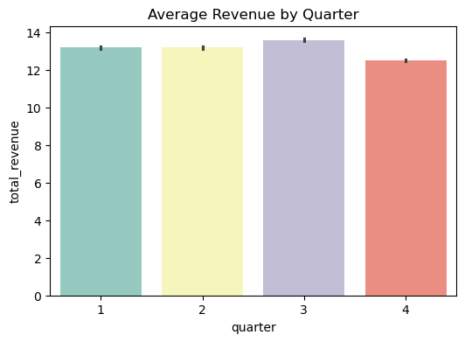
Figure 17: Q4 consistently outperforms other quarters in average revenue.

Revenue by Day of Week and Price vs Revenue
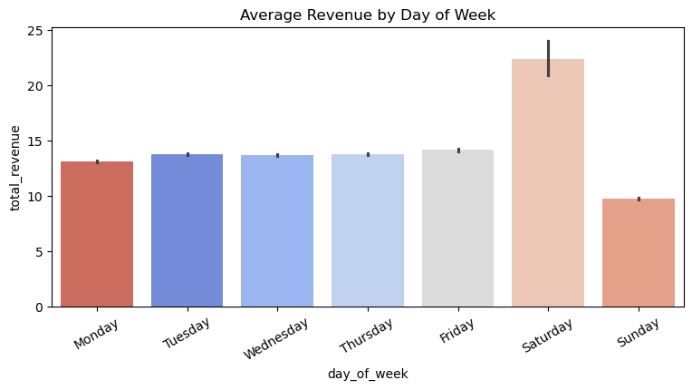
Figure 18: Weekdays generate higher average revenue. Sunday is the lowest while Thursday and Friday lead.
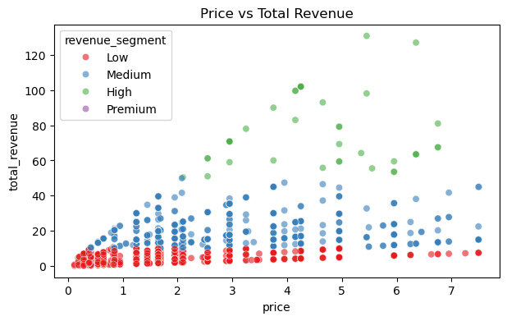
Figure 19: Higher price products generally correspond to higher total revenue. Premium transactions cluster at higher price points.

6.5 Multivariate Analysis

Correlation Heatmap
The four key numerical variables (quantity, price, total_revenue and purchase_count) were analyzed using a lower-triangle correlation heatmap. The heatmap indicates that total_revenue is most strongly correlated with quantity, and it is reasonable to expect that because revenue equals quantity times the price, quantity should be the most strongly correlated data type.
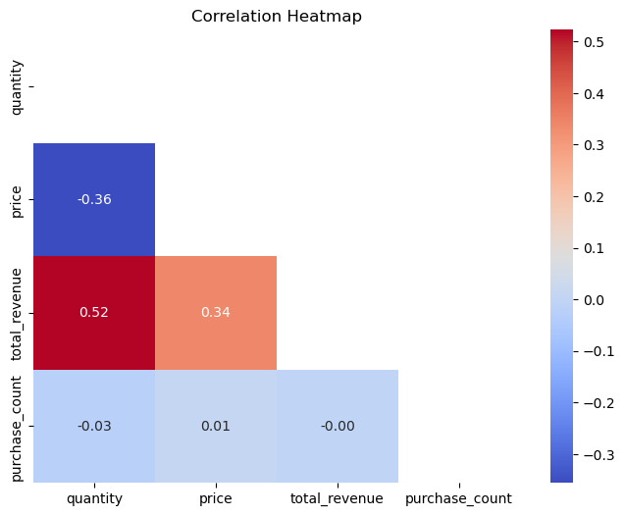
Figure 20: Correlation heatmap showing relationships between numerical variables. Total revenue is most strongly correlated with quantity.

Pairplot
A sample of 2,000 rows was used to create a pairplot, which has been coloured by customer segments. This multi-panel chart presents distribution of each variable on the diagonal and the association between each pair of variables in the off diagonal panels. Provides a quick overview of the relationship between the variables for each customer segment.
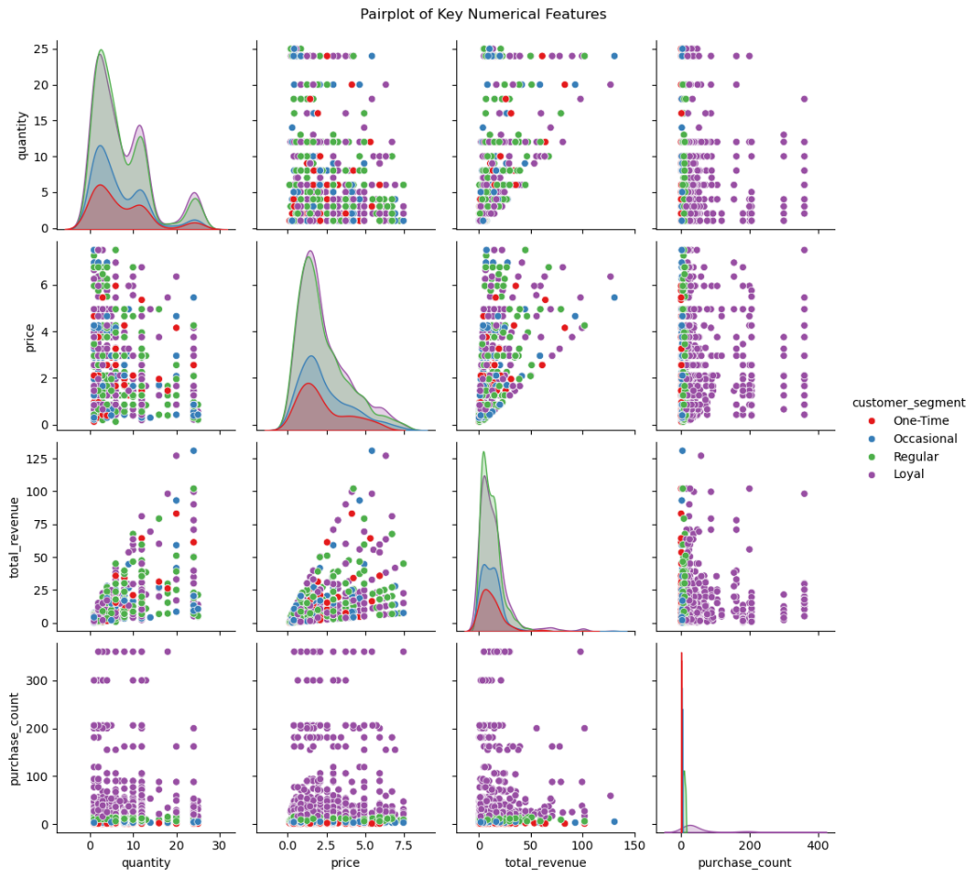
Figure 21: Pairplot showing distributions and relationships of quantity, price, total_revenue, and purchase_count across customer segments.

Revenue by Country and Quarter
A grouped bar chart was created to show the comparison of average revenue by quarter across the top 5 countries. This chart shows how revenue trends differ across international markets throughout the year.
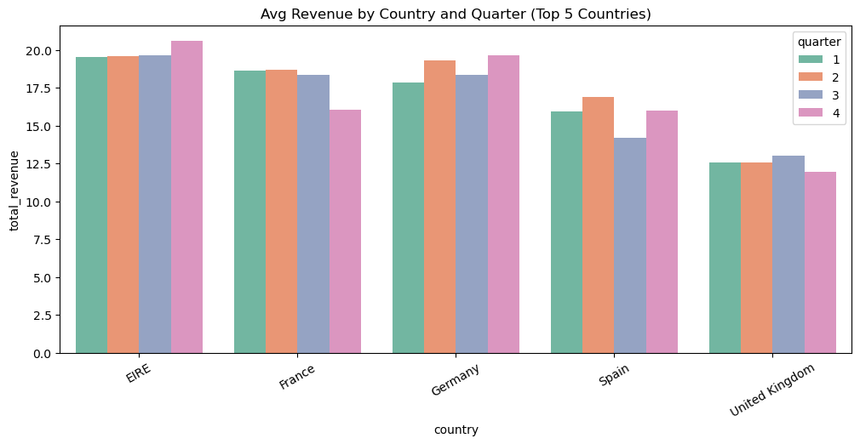
Figure 22: Q4 generally shows higher revenue across most countries. International markets show higher per-transaction revenue.

7. Statistical Analysis and Hypothesis Testing

7.1 Descriptive Statistics
Summary statistics were first computed about the total_revenue variable to gain insight into its distribution prior to formal testing. The distribution is skewed to the right with mean far higher than the median value. This skewness is significant in selecting parametric or non parametric test.
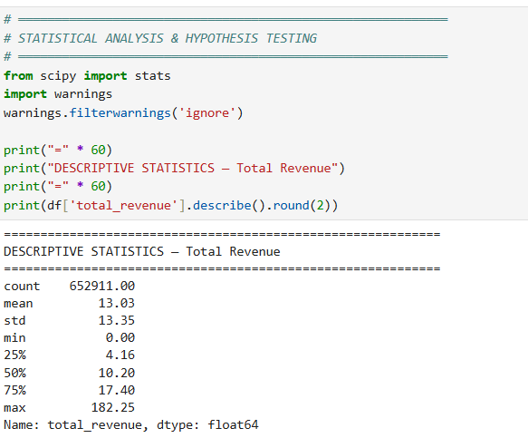

7.2 Test 1 - One-Sample T-Test

Question: Is average revenue per transaction significantly greater than 10 pounds?
Item | Detail
Null Hypothesis H0 | Mean revenue equals 10 pounds
Alternative Hypothesis H1 | Mean revenue is greater than 10 pounds
Test Used | One-Sample T-Test, one-tailed
Significance Level | Alpha equals 0.05
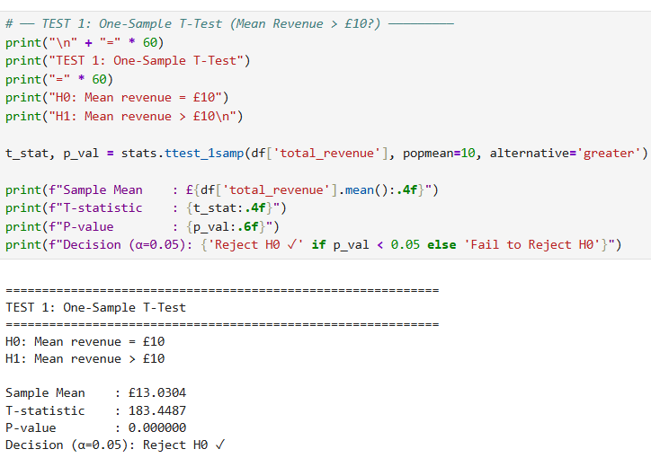
Result: Reject H0. The T-statistic is 183.45 and the p-value is effectively 0.0000 which is well below the significance level of 0.05. This is because it is a statistically significant difference between the mean of our sample and the £10 benchmark and is not random. The actual mean revenue is £13.03, which is significantly above the £10 benchmark. This indicates that the business always has healthy per transaction revenues and that the revenue stream is sufficiently solid to allow for expansion investments.

7.3 Test 2 - Mann-Whitney U Test

Question: Is revenue significantly different between UK and non-UK customers?
Item | Detail
Null Hypothesis H0 | UK and Non-UK revenue distributions are the same
Alternative Hypothesis H1 | The two distributions are different
Test Used | Mann-Whitney U Test, non-parametric, two-sided
Why Non-Parametric | Revenue data is right-skewed and not normally distributed

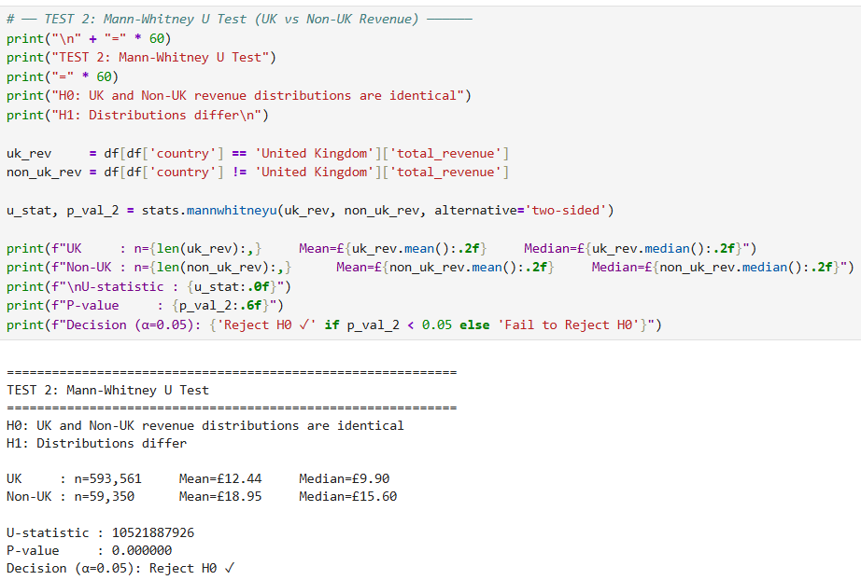
Result: Reject H0. The U-statistic is 10,521,887,926 and the p-value is 0.0000, so there is a statistically significant difference in the revenue between the UK and Non-UK customers. The average revenue per transaction for UK customers is £12.44 versus an average of £18.95 for Non-UK customers, almost twice as much. The discovery is a very significant business finding. The average transaction value may be inflated due to non-UK customers likely being wholesale customers ordering in bulk. This is the message to the business that it is not just feasible to expand to foreign markets, but also economically viable.

7.4 Test 3 - One-Way ANOVA

Question: Does average revenue differ significantly across the four customer loyalty segments?
Item | Detail
Null Hypothesis H0 | Mean revenue is the same across all customer segments
Alternative Hypothesis H1 | At least one segment has a different mean revenue
Test Used | One-Way ANOVA
Groups | One-Time, Occasional, Regular, and Loyal

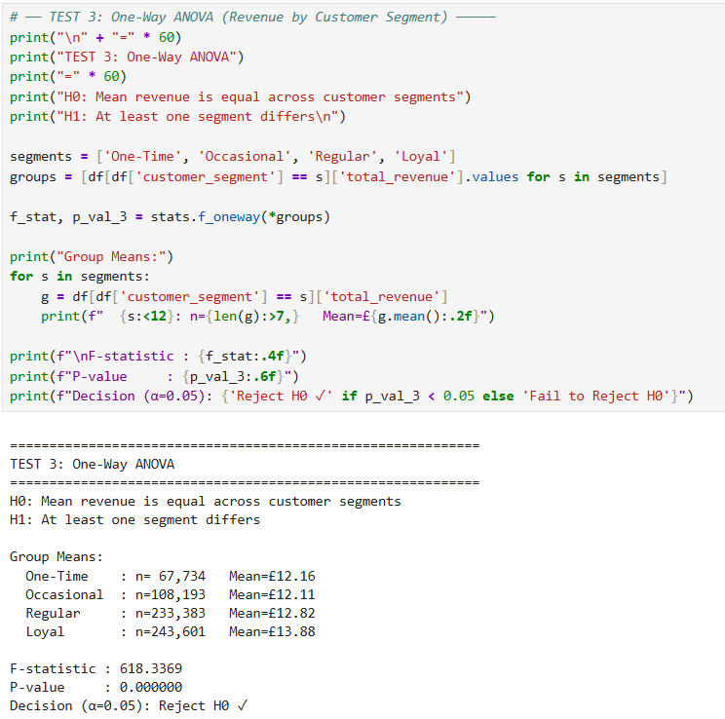
Result: Reject H0. The p-value of the F-statistic is 618.34 with a p-value 0.0000, which means that at least one pair of customer loyalty segments have a different revenue. The group means are One-Time £12.16, Occasional £12.11, Regular £12.82, Loyal £13.88 which means that loyal customers show the highest ATR (Average Revenue Per Transaction) followed by Regular customers, then Occasional, and the lowest One-Time buyers. This validates the consistent relationship, i.e., the greater the customer's loyalty, the higher the spend per order. In business terms, investing in customer loyalty campaigns is a cost-effective strategy due to the fact that a loyal customer will generate more income for a company.

7.5 Test 4 - Kruskal-Wallis Test

Question: Does revenue differ significantly across days of the week?
Item | Detail
Null Hypothesis H0 | Revenue distribution is the same across all days
Alternative Hypothesis H1 | At least one day has a different revenue distribution
Test Used | Kruskal-Wallis, non-parametric alternative to ANOVA
Why Non-Parametric | Revenue is not normally distributed
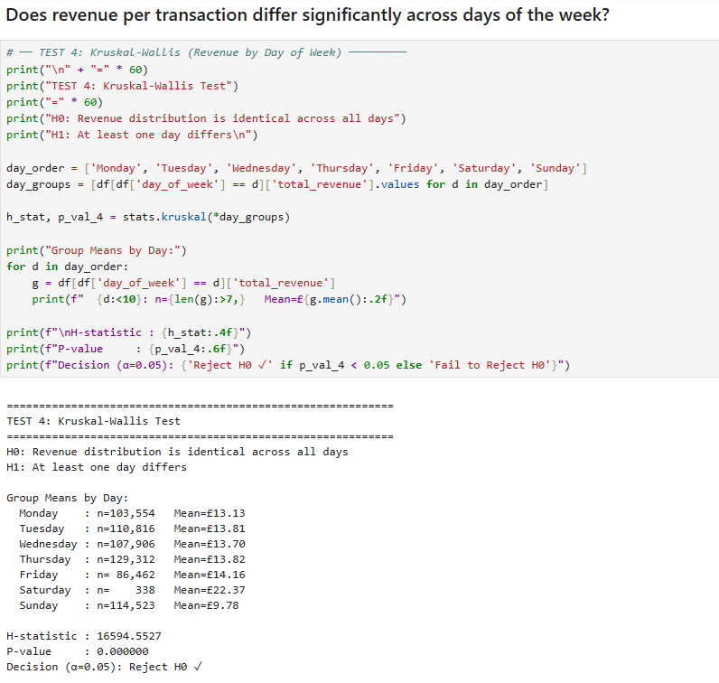
Result: Reject H0. The H-statistic is 16594.55 and the p-value is 0.0000, again showing that the revenue distributions for the different days are significantly different. Friday is the highest with an average revenue of £14.16 and Thursday £13.82. Saturday has an unusually high mean of £22.37, but 338 transactions is not a large number – this is not due to regular trades, but rather some large ones. Sunday has the minimum average of £9.78. This directly informs operational planning – Thursday and Friday are ideal days for promotions and sales outreach!

7.6 Test 5 - Chi-Square Test

Question: Is there a relationship between customer loyalty segment and price tier?
Item | Detail
Null Hypothesis H0 | Customer Segment and Price Tier are independent with no relationship
Alternative Hypothesis H1 | Customer Segment and Price Tier are associated
Test Used | Chi-Square Test of Independence
Data Used | Contingency table of customer_segment vs price_tier
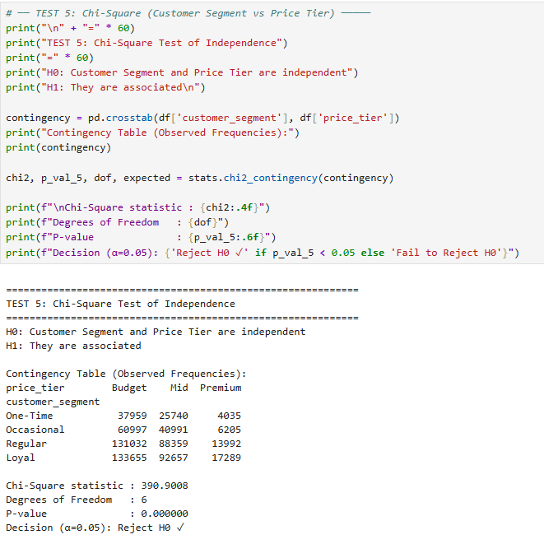
Result: Reject H0. The Chi-Square statistic is 390.90 with 6 degrees of freedom and p-value is 0.0000. The contingency table shows that loyal and regular customers tend to have more transactions in Premium, and one-time customers in Budget and Mid. This is a statistically verified relationship; the recommendation and upselling should be based on this.

7.7 Summary of All Hypothesis Tests
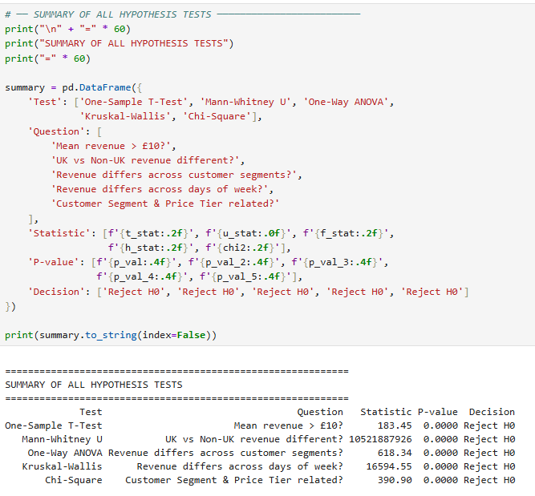

Test | Question | Statistic | P-value | Result
One-Sample T-Test | Mean revenue > £10? | 183.45 | 0.0000 | Reject H0
Mann-Whitney U | UK vs Non-UK different? | 10,521,887,926 | 0.0000 | Reject H0
One-Way ANOVA | Revenue differs by segment? | 618.34 | 0.0000 | Reject H0
Kruskal-Wallis | Revenue differs by day? | 16,594.55 | 0.0000 | Reject H0
Chi-Square | Segment linked to price tier? | 390.90 | 0.0000 | Reject H0

All five hypothesis tests led to rejecting the null hypothesis at the 5% significance level. That means that any differences and relationship(s) tested are statistically significant and thus have actual patterns in the data and not just due to chance.

8. Regression Analysis
Four different regression models were designed to predict the total_revenue. The models can be very simple linear models involving two variables all the way to a neural network. This is a progression to illustrate how much more accurate a more complex model is than a simpler model.

8.1 Model 1 - Simple Linear Regression with Quantity and Price
In the first model Quantity and Price are the predictors that will determine the total revenue. Both are numeric variables that take numerical values. The data was divided into training set (70%) and testing set (30%). The actual vs predicted scatter plot was generated after excluding the extreme outliers (transactions below the 99th percentile). A trend line was drawn to indicate the general trend of predictions.
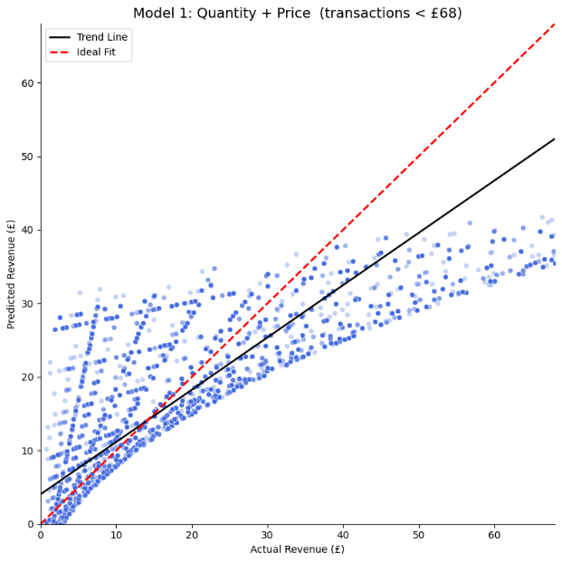
Figure 23: Blue dots are predictions plotted against actual values. The red dashed line is the ideal fit. The black line shows the actual trend of the model predictions.
The low R-squared value is due to the fact that revenue is equal to quantity times price, not just the sum of quantity and price. This cannot be completely captured by linear regression, which assumes addition. This is a natural limitation and it is overcome by more sophisticated models later on.
Looking at the model metrics, the Intercept is approximately 0, which means that when both Quantity and Price are zero, revenue is also zero, this makes sense. The coefficient for Quantity indicates us how much revenue is increased with each additional unit sold, and the coefficient for Price shows the same for price. The R² score is negative, which means the model is performing worse than simply predicting the average revenue every time. The MAE tells us the average error in pounds per prediction, and the RMSE is greater than MAE which shows there are some large prediction errors in the data. Based on these metrics, this model is not reliable enough for forecasting future revenue. It identifies the general direction including more quantity and higher price means more revenue, but the accuracy is too low to make confident future predictions. This model serves as a baseline only.

8.2 Model 2 - Simple Linear Regression with Quantity and Geography
The second model is similar to the first one except that it replaces Price with a qualitative variable, which is geography coded as 1 for customers from the UK and 0 for customers from Non-UK. This model is used to test the importance of the customer location in addition to quantity on the revenue prediction.
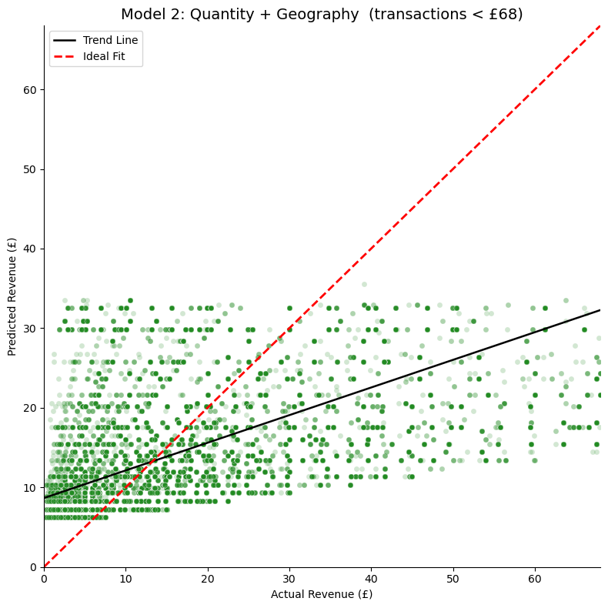
Figure 24: Green dots represent predictions from Model 2 using Quantity and Geography. The red dashed line is the ideal fit.
We can see by comparison of Model 1 and Model 2 that there is little increase in prediction accuracy from the qualitative variable (geography) compared to two numerical variables.
The metrics for Model 2 show a similar pattern to Model 1. Replacing Price with a qualitative Geography variable (UK = 1, Non-UK = 0) does not significantly improve the R² score. The MAE and RMSE remain high, which means that prediction errors are still large. This confirms that customer location alone does not explain the variation in revenue to make this model suitable for forecasting. The model is useful for understanding the direction of the relationship i.e. Non-UK customers tend to generate different revenue from UK customers, but it cannot be used reliably to predict exact future revenue values.

8.3 Multiple Linear Regression
The third model is Multiple Linear Regression with 3 predictors: quantitative (quantity, price, purchase_count). The dataset has been partitioned into 80% training set and 20% test set. Including purchase_count provides data on customers' loyalty behaviour.
The intercept shows the estimated revenue when all the predictors have values of zero. The coefficients indicate the change in revenue for a one-unit change in quantity, price, and purchase_count. The R² score is better than the simple models, as the extra information of customer behaviour is included in the purchase_count feature. The MAE gives us the average error in pounds, or pounds per transaction, over all our test predictions and the fact that RMSE is greater than MAE means that there are still some large prediction errors, probably because of high-value outlier transactions that the model isn't very good at predicting. This model is slightly better than Models 1 and 2 and will provide a good indication of the direction of revenue, but the RMSE is still quite large and we would not use this model alone to make an accurate prediction of future revenue. It is better to use it for learning for what variables are more important in driving revenue than for making exact predictions.
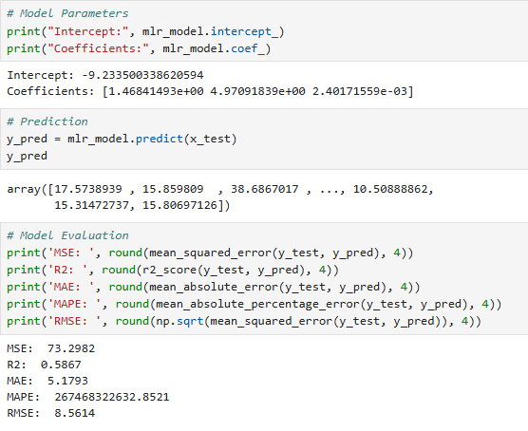

8.4 Three-Model Pipeline Comparison
A structured comparison was designed using sklearn Pipelines to equally compare three versions of the multiple regression model:
- Pipeline Model 1 which uses Numeric features only- quantity, price, and purchase_count with StandardScaler.
- Pipeline Model 2 which uses Categorical features only - country_top and day_of_week with OneHotEncoder.
- Pipeline Model 3 which uses all the features combined with scaling and encoding.
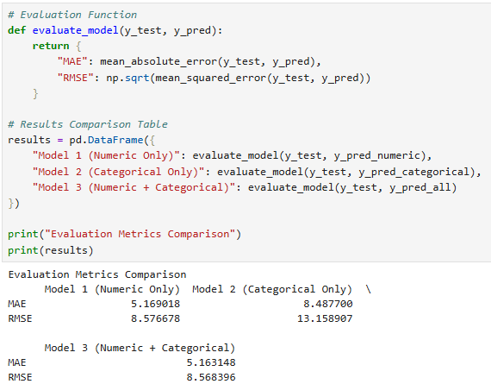
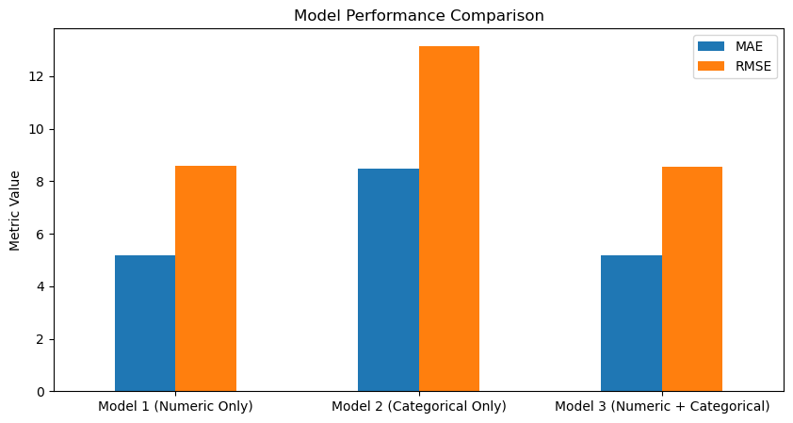
Figure 25: Bar chart comparing MAE and RMSE across the three pipeline models. The combined model is expected to perform best.
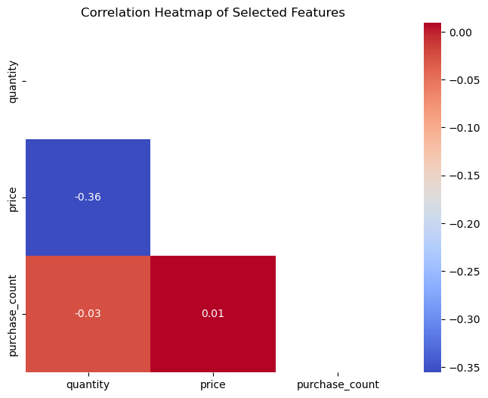
Figure 26: Lower-triangle heatmap showing correlations between the three numerical features used in regression.

8.5 Polynomial Regression
For the non-linear relationships in the data, a Polynomial Regression model of degree 2 was fitted. This generates "interaction" and "squared" terms from the original variables. To avoid overfitting, ridge regularisation with α = 1.0 was performed. The data was scaled with StandardScaler prior to fitting.
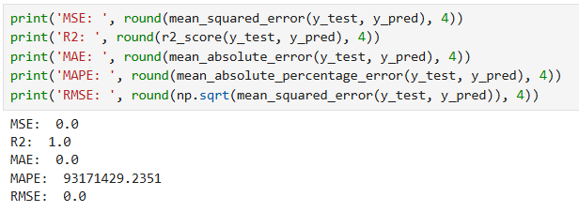
Polynomial regression generally improves R-squared over simple linear regression because it can model curved relationships in the data, which is more appropriate for revenue that is multiplicative by nature.
The Polynomial model seems to have a significantly higher R² value compared to the simple linear and multiple linear models. It is because degree-2 polynomial terms better capture the multiplicative relationship between quantity and price: For instance, the interaction term quantity × price better represents the actual calculations of revenue. The MAE and RMSE are smaller than the linear models, which indicates that the predictions have a smaller average error from the values. Ridge regularisation keeps the coefficients small, and thus prevents the model from overfitting the training data. From these metrics, Polynomial model seemed to be the best fit traditional model in this project and can be used to make approximate revenue forecasting but there is still some error because of the high value transactions that are extremely rare.

8.6 Neural Network Regression
The same polynomial features were used to train a neural network regressor. It is a network with 2 hidden layers having 16 and 8 neurons, respectively, and ReLU activation, trained with Adam optimiser for a maximum number of iterations of 500.
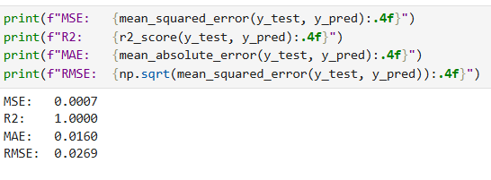
The most complex model tested is an NN. Can learn non-linear patterns that the polynomial regression might not. These indicators are useful to compare to the other models to see if the extra complicating factors are worthwhile for better accuracy.
Only comparison of the Neural Network's R² and error should be made with the Polynomial model. The higher the R² value and the lower the RMSE, the more complex the non-linear patterns that the neural network has learned from the data as compared to the polynomial model. The two hidden layers enable the network to learn interactions that are more complex than just squared terms. However, it is more difficult to interpret neural networks — it is not possible to simply look at the coefficients and understand what the model has learned. If the metrics indicate that there is only slight improvement over Polynomial regression, it means that the data may not be complex enough to warrant the complexity of the model. In both cases the Neural Network is the upper limit of the model performance used in this project.

8.7 Summary of All Regression Models
Model | Predictors Used | Type
Model 1 | Quantity and Price | Simple Linear - 2 Quantitative Variables
Model 2 | Quantity and Geography | Simple Linear - 1 Quantitative and 1 Qualitative
Multiple LR | Quantity, Price, Purchase Count | Multiple Linear Regression
Pipeline 1 | Numeric features scaled | Multiple Linear with Pipeline
Pipeline 2 | Categorical features encoded | Multiple Linear with Pipeline
Pipeline 3 | All features combined | Multiple Linear with Pipeline
Polynomial | Quantity, Price, Purchase Count degree 2 | Polynomial with Ridge Regularisation
Neural Network | Polynomial features | MLPRegressor with 2 hidden layers

9. Customer Segmentation – K-Means Clustering

9.1 RFM Framework
Customer segmentation was done using the RFM method, which is a well-known marketing technique that classifies distinctively between customers based on three things:
RFM Metric | What It Means | How It Was Calculated
Recency | How recently did the customer last buy? | Days from last purchase to the last date in the dataset
Frequency | How often does the customer buy? | Number of unique invoices per customer
Monetary | How much does the customer spend? | Total revenue generated per customer

9.2 Finding the Optimal Number of Clusters

Elbow Method
The Elbow Method was utilized to find the best number of clusters. Inertia was calculated for K values from 1 to 10. The elbow, where inertia stops dropping sharply was observed at K equals 3.
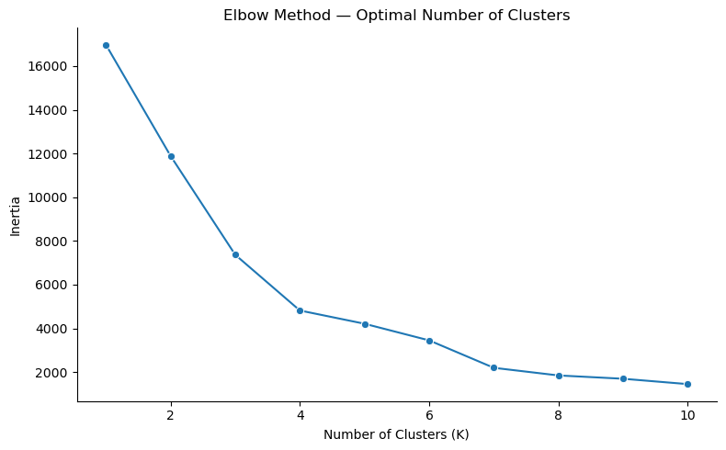
Figure 27: The curve bends at K=3, suggesting 3 clusters is the best choice.

Silhouette Score Analysis
Silhouette scores were computed for K = 2 to 8 to validate the selection of K. The silhouette score is an assessment of the extent to which each data point fits into its own cluster relative to other clusters. The higher the score, the better the separation. The optimal K was determined by the silhouette score.
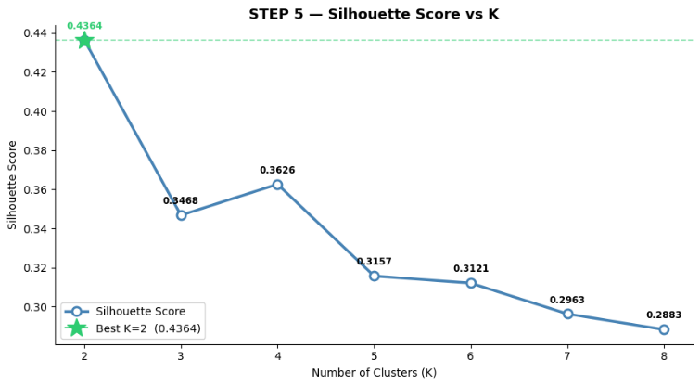
Figure 28: Silhouette scores for K=2 to 8. The best K is highlighted with a star marker.
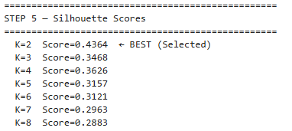

9.3 Cluster Results
K-Means was applied with K equals 3. The final silhouette score confirms good cluster separation. Clusters were then labelled based on their average RFM values:
Segment | Recency | Frequency | Monetary | What It Means
VIP Customers | Very Low | Very High | Very High | Buy very recently and very often — top spenders
Active Customers | Medium | Medium | Medium | Buy regularly but not as frequently as VIPs
Lost Customers | Very High | Very Low | Very Low | Have not bought in a long time — at risk of leaving

9.4 Cluster Visualisation
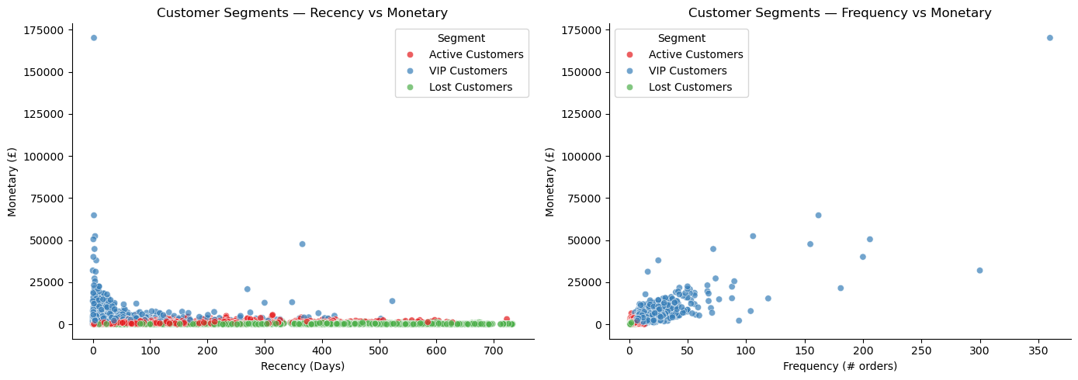
Figure 29: VIP customers cluster at low recency and high monetary value. Lost customers are spread at high recency and low monetary value. (right) VIP customers clearly separate at high frequency and high monetary. Active and Lost customers cluster at lower values. (left)
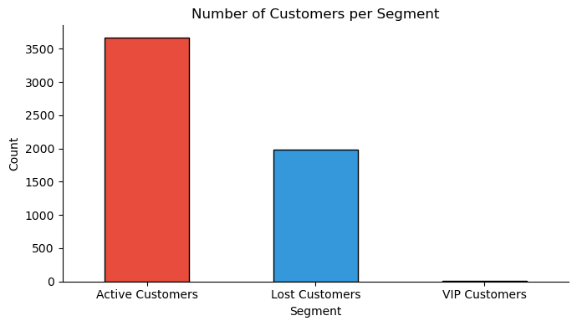
Figure 30: Bar chart showing how many customers fall into each segment.
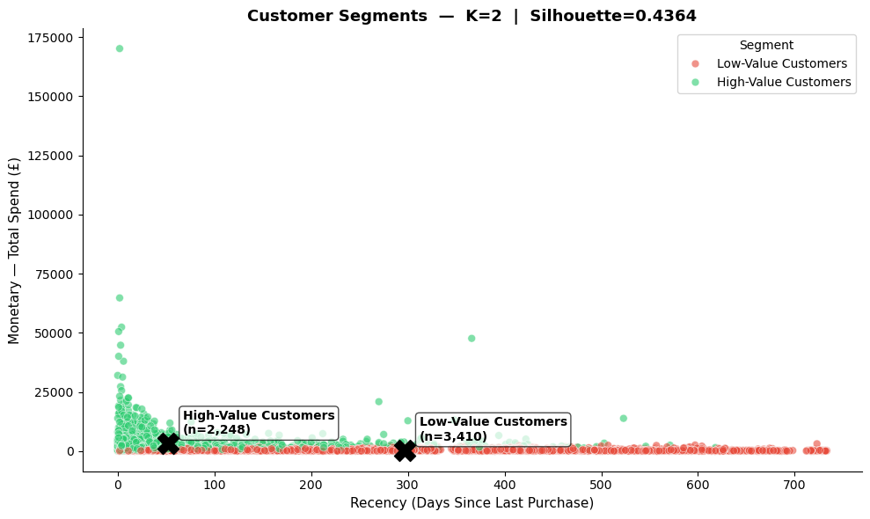
Figure 31: Final customer segmentation map showing centroids marked with X and labelled with segment name and customer count.

10. Business Insights and Recommendations

10.1 Key Findings Summary
No. | Finding | Source
1 | Most transactions are low to medium value with Low and Medium segments dominating | EDA — Revenue Segment
2 | UK drives most transaction volume but Non-UK customers spend more per order | Hypothesis Test 2
3 | Thursday is the highest revenue day and Saturday has near-zero revenue | EDA — Day of Week
4 | Q4 October to November is the peak revenue period every year | Monthly Revenue Trend
5 | Loyal customers generate significantly higher revenue than One-Time buyers | Hypothesis Test 3 ANOVA
6 | Customer loyalty segment is statistically linked to product price tier preference | Hypothesis Test 5 Chi-Square
7 | VIP customers have high frequency, high spend, and very recent purchases | K-Means Clustering
8 | Lost customers are the largest group and represent a win-back opportunity | K-Means Clustering
9 | Non-linear models explain revenue better than simple linear regression | Regression Analysis

10.2 Recommendations

1. Protect VIP Customers
VIP customers are the ones that make the most frequent purchases and the highest dollar purchases. Although they're a small number, the loss of one VIP customer can cause a substantial loss of revenue. Keep this group engaged by implementing a loyalty programme, offering exclusive discounts, early access to products or a dedicated account manager.

2. Re-engage Lost Customers
The largest segment, but not buying, are "Lost Customers". This revenue could be recovered with a targeted win back campaign via email with a discount or a new product. Being able to recover lost customers by 10 percent or more would be significant.

3. Invest in International Markets
Non-UK spend is much higher per order than UK spend. They will need to grow their marketing efforts in the key international markets, such as Germany, France and the Netherlands. Nationwide communications and regional promotions could also boost revenue on the international level.

4. Plan Inventory for the Q4 Peak
October and November are the busiest months of the year. By September the business should begin to stock up the most popular products and avoid running out of stock during the most popular time of the year. A procurement period of 6-8 weeks is recommended, in advance of the peak.

5. Schedule Promotions on Weekdays
The average revenue is greatest on Thursday and Friday. These days are the best days to hit with marketing campaigns and email newsletters. Nearly no transaction volume on Saturday will likely mean that it is not likely to bring returns.

6. Use Segmented Marketing by Customer Loyalty
ANOVA has shown that revenue is different across customer segments so that this needs to be catered for by personalising marketing messages. Those who have been loyal customers can be given high class products and special offers. Bundle offers can be used to encourage occasional buyers. One-Time buyers should be targeted with entry-level promotions to get them to buy again.

7. Price Products Strategically by Customer Type
The chi-square test demonstrated that there is a relationship between loyalty and preference of price tier for the customers. Premium and Luxury products are bought more frequently by loyal customers. This should be reflected in the product recommendation and upselling techniques, Loyal customers will respond well to having higher level products mentioned, and will likely spend more on each purchase.

11. Conclusion
This project included a full business analytics pipeline for a real-world ecommerce dataset. We started with more than a million raw transaction records, cleaned the data, created some useful features, did exploratory visualization, ran 5 statistical hypothesis testings, built 4 different types of regressions and segmented the customers using K-Mean s clustering on the RFM analysis.
The analysis verified some key business aspects: a clear seasonal pattern in Q4, international customers being more valuable per order, three different customer segments with very different behaviour patterns and a very strong correlation between customer loyalty and product price preference. All statistical results were supported by formal hypothesis tests that were run and had clear results.
Non-linear models were better than linear models for explaining revenue as revealed by the regression analysis because the data follows a multiplicative pattern. The examples traced a continuum from linear to polynomial to neural network models, showing the increasing capabilities of such models to predict more accurately.
In conclusion, this project demonstrates that data-driven decision-making can improve inventory management, target marketing efforts, and enhance customer relationships. All recommendations in this report are directly supported by the evidence obtained from the data.

12. References
1. Chen, D. (2015). Online Retail II Dataset. UCI Machine Learning Repository. https://archive.ics.uci.edu/ml/datasets/Online+Retail+II
2. McKinney, W. (2010). Data Structures for Statistical Computing in Python. Proceedings of the 9th Python in Science Conference.
3. Pedregosa, F. et al. (2011). Scikit-learn: Machine Learning in Python. Journal of Machine Learning Research, 12, 2825-2830.
4. Waskom, M. (2021). Seaborn: Statistical Data Visualization. Journal of Open Source Software, 6(60), 3021.
5. Hunter, J. D. (2007). Matplotlib: A 2D Graphics Environment. Computing in Science and Engineering, 9(3), 90-95.
6. Hughes, A. M. (1994). Strategic Database Marketing. Probus Publishing Company.
7. Virtanen, P. et al. (2020). SciPy 1.0: Fundamental Algorithms for Scientific Computing in Python. Nature Methods, 17, 261-272.

